Points of Note – NWPC 06/03/2023
National Teams
The plan for this season is to proceed with entries to the below tournaments:
- Senior Women – Home Nations, Ireland
- Senior Men – Home Nations, Ireland
- U17 Girls – European Championship, Turkey
- U17 Boys – Qualifications for European Championship, Romania
- U15 Girls - European Championship, Croatia
- U15 Boys - European Championship, Montenegro

The decision to enter these competitions was based on the following:
- LEN decided that U15 Boys, U15 Girls and U17 Girls will not have a qualification round in the Europeans.
- Originally LEN had decided that qualification rounds would remain in place for our Senior Teams and U17 Boys. However, LEN then decided to go ahead without qualification rounds for Seniors. This had a huge impact on the NWPC finances so therefore we have had to make a decision to withdraw the Seniors and focus on the Home Nations tournament.

All club secretaries were sent an email providing information on National Training Squad Competitions and entry fees on 3rd March.

Click here for the upcoming National Teams Training Sessions
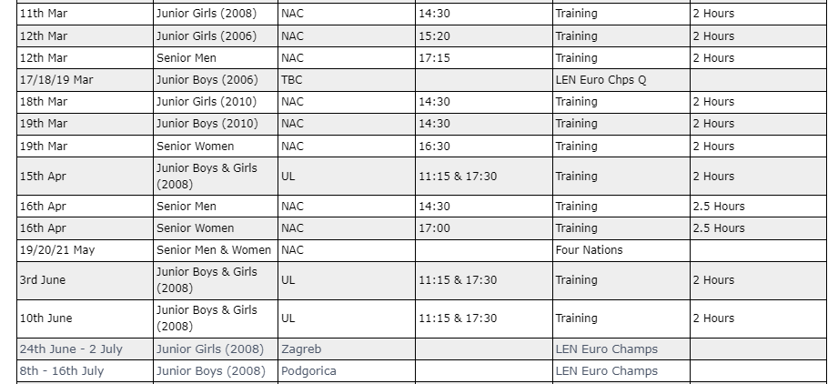

Waterpolo Development Pathway
A discussion was held with the National Head Coach around the development pathway for National Squads. It was noted that the existing National Squad Selection Policy clearly outlines the selection process for National Teams. However, it was agreed that this can be developed further to include the National Standard Skills required to be chosen for a National Team.

Cup and Survey Feedback
The NWPC reviewed the feedback received from the following three surveys:
- Ireland Waterpolo End of Year Survey, 2023 National League Division 1 Cup & 2023 Irish U17 Cups.
Some of the recommendations can be implemented immediately such as Streaming of the Cup draw, while others need to be reviewed by the Competition and Referees Committees.

National League Structure
A review of the National league will take place to ascertain if changes can be made to facilitate the feedback received from clubs. This review will be carried out by the Competitions Committee. Three key things were noted with regards to the league review:

- Fixture changes occur particularly at the start of the season because clubs are withdrawing teams from leagues. The withdrawal of a team, has a knock-on effect to how that particularly league can be run, and all games already scheduled then need to be changed and re-scheduled, preventing the release of fixtures well in advance of upcoming games.

- Availability of pool time dictates when games can be held. The pool time currently available to the NWPC is in blocks of 4/6 hours on a Saturday or Sunday. Unfortunately, a full day of pool time is not available in either Galway, Belfast or Dublin, which therefore limits the ability to schedule multiple games for a club in one day.

- The availability of officials restricts the ability to schedule league games concurrently in three different venues.

Irish Senior Cup Draw
The draw took place in the presence of the committee, in Irish Sport HQ. A recording of the draw was emailed out to Club Secretaries on Saturday 4th March.

The Ladies Cup Groups
The Men’s Cup Groups

Education
Level 1 and Level 2 Virtual Classroom dates have been set for 2023 and available on our website.. The Qualification Timeline outlines each of the steps involved in gaining a qualification.

Upcoming CPDS for Waterpolo

A Water Polo Coaching Conference provisionally planned for 10 September.

Next Meeting | TBC

